Group K Members:
Oarabeng Khunou (600542
Ditheto Mashiane (603001)
Reitumetse Given Moreke (601947)
Module: DBD 361

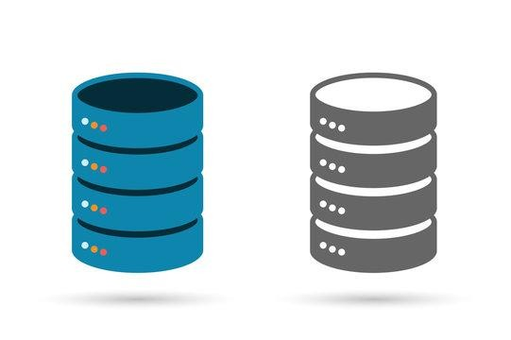

Table of Contents
Milestone 1 3
Introduction 3
Scope of the database 3
Objectives of the database system 3
Constraints 4
Conceptual Model 4
Justification of 3NF 5
Logical Design 5
Physical Design 6

Milestone 1

Introduction
Background
Tasty Bitez is a small fast-food restaurant located in Theresa Park Pretoria North, they provide various number of food choices on their menu like kota’s, burgers, sandwiches, grilled meat even beverages. They have been open for quite some time and look forward to expanding their business and as well as build a place where customers can sit and eat as currently their services mainly revolve around take aways, they give you an option where you can order when arrive and leave, order online and collect your food later.

Problem statement
The issue that Tasty Bitez faces is that when it gets full and due to being under stuff it leads to slow service and on top of that they manually record their orders, by writing the orders in a book which leads to them sometimes mixing the customer’s orders and they have to keep track of who has to pay so that they don’t give out their orders thinking customers paid. The second problem that they face is stock shortages from to time when they are preparing order’s they realize their inventory is running low.

Scope of the database
The database for Tasty Bitez will focus on the following core business operations:
- Order Management: Digital storage of orders to improve accuracy.
- Payment Processing: Automated tracking to eliminate errors.
- Inventory Monitoring: Real-time stock updates to prevent shortages.
- Operational Efficiency: Reducing order processing time and improving

Objectives of the database system
The key objectives of the database are:
- Improve order accuracy: The database will ensure that customer orders are stored digitally to prevent mistakes or orders getting mixed up
- Improve inventory: The database will track the quantity of the available stock of each item to prevent stock from running out
- Optimize payment tracking: It will keep an accurate record of all payments and outstanding balances.
- Increase operational efficiency: It will reduce the amount of time it takes to manually record orders and doing inventory checks

Constraints
- Limited budget: The business operates as a small enterprise so the business cannot afford a high-end database server
- Staff training: The staff may need training on how to use the new system implemented

Conceptual Model

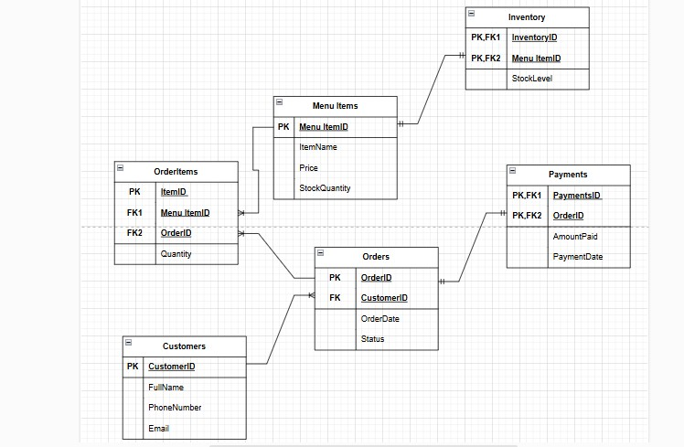

Justification of 3NF
First Normal Form (1NF)
- Eliminated duplicate columns: Each order contains multiple menu items stored in a separate table (OrderItems)
- Atomic Data Storage: A customer’s FullName is stored as a single value rather than FirstName + LastName
- Each column contains only one type of data: No multiple phone numbers or emails in a single field
Second Normal Form (2NF)
- Must be in 1NF
- Customers have been separated between customers table and orders table to remove redundant data
Third Normal Form (3NF)
- Must be in 2NF
- Removed the total amount attribute and calculated it dynamically using the OrderItems and MenuItems tables thus there is no data redundancy and no unnecessary dependencies

Logical Design
Table Name | Columns
Customers | CustomerID (PK, INT IDENTITY(1,1)), FullName (VARCHAR(100)), PhoneNumber (VARCHAR(15) UNIQUE), Email (VARCHAR(100) UNIQUE)
Orders | OrderID (PK, INT IDENTITY(1,1)), CustomerID (FK, INT), OrderDate (DATETIME DEFAULT GETDATE()), Status (VARCHAR(20) CHECK (Status IN ('Pending', 'Completed', 'Cancelled')))
OrderItems | ItemID (PK, INT IDENTITY(1,1)), OrderID (FK, INT), MenuItemID (FK, INT), Quantity (INT CHECK (Quantity > 0))
MenuItems | MenuItemID (PK, INT IDENTITY(1,1)), ItemName (VARCHAR(50) UNIQUE), Price (DECIMAL(10,2) CHECK (Price > 0))
Payments | PaymentID (PK, INT IDENTITY(1,1)), OrderID (FK, INT), AmountPaid (DECIMAL(10,2) CHECK (AmountPaid >= 0)), PaymentDate (DATETIME DEFAULT GETDATE())
Inventory | InventoryID (PK, INT IDENTITY(1,1)), MenuItemID (FK, INT), StockLevel (INT CHECK (StockLevel >= 0))

Physical Design
- DMBS: Microsoft SQL server 2022
- Database Server: Local SQL Server Instance
- File Organization: Tables stored in separate files for performance.
Security Measures:
- Role-based access control (RBAC) – Staff cannot modify payments or access sensitive records.
- Encryption – Sensitive data like PhoneNumber and Email is encrypted.
- Authentication required – Employees must log in to use the system.
Relationships:
- Customers → Orders (1-to-Many)
- Orders → OrderItems (1-to-Many)
- MenuItems → OrderItems (1-to-Many)
- Orders → Payments (1-to-1)
- MenuItems → Inventory (1-to-1)
Performance Optimization:
- Indexes – Added to OrderDate, MenuItemID, and CustomerID for faster search queries.
- Stored Procedures – Implemented for common queries to improve efficiency.

Milestone 2
CREATE DATABASE TastyBitez;
GO

USE TastyBitez;
GO

-- Create Customers Table
CREATE TABLE Customers (
CustomerID INT IDENTITY(1,1) PRIMARY KEY,
FullName VARCHAR(100) NOT NULL,
PhoneNumber VARCHAR(15) UNIQUE NOT NULL,
Email VARCHAR(100) UNIQUE NOT NULL
);

-- Create MenuItems Table
CREATE TABLE MenuItems (
MenuItemID INT IDENTITY(1,1) PRIMARY KEY,
ItemName VARCHAR(50) UNIQUE NOT NULL,
Price DECIMAL(10,2) CHECK (Price > 0) NOT NULL
);

-- Create Inventory Table
CREATE TABLE Inventory (
InventoryID INT IDENTITY(1,1) PRIMARY KEY,
MenuItemID INT NOT NULL UNIQUE,
StockLevel INT NOT NULL CHECK (StockLevel >= 0),
FOREIGN KEY (MenuItemID) REFERENCES MenuItems(MenuItemID) ON DELETE CASCADE
);

-- Create Orders Table
CREATE TABLE Orders (
OrderID INT IDENTITY(1,1) PRIMARY KEY,
CustomerID INT NOT NULL,
OrderDate DATETIME DEFAULT GETDATE(),
Status VARCHAR(20) NOT NULL DEFAULT 'Pending' CHECK (Status IN ('Pending', 'Completed', 'Cancelled')),
FOREIGN KEY (CustomerID) REFERENCES Customers(CustomerID) ON DELETE CASCADE
);

-- Create OrderItems Table
CREATE TABLE OrderItems (
ItemID INT IDENTITY(1,1) PRIMARY KEY,
OrderID INT NOT NULL,
MenuItemID INT NOT NULL,
Quantity INT CHECK (Quantity > 0) NOT NULL,
FOREIGN KEY (OrderID) REFERENCES Orders(OrderID) ON DELETE CASCADE,
FOREIGN KEY (MenuItemID) REFERENCES MenuItems(MenuItemID)
);

-- Create Payments Table
CREATE TABLE Payments (
PaymentID INT IDENTITY(1,1) PRIMARY KEY,
OrderID INT NOT NULL,
AmountPaid DECIMAL(10,2) CHECK (AmountPaid >= 0) NOT NULL,
PaymentDate DATETIME DEFAULT GETDATE(),
FOREIGN KEY (OrderID) REFERENCES Orders(OrderID) ON DELETE CASCADE
);

-- Indexes
CREATE NONCLUSTERED INDEX idx_customer_email ON Customers (Email);
CREATE NONCLUSTERED INDEX idx_order_status ON Orders (Status);
CREATE NONCLUSTERED INDEX idx_menu_price ON MenuItems (Price);
go;
-- Triggers
-- Auto-create inventory entry for new menu items
CREATE TRIGGER trg_CreateInventoryEntry
ON MenuItems
AFTER INSERT
AS
BEGIN
INSERT INTO Inventory (MenuItemID, StockLevel)
SELECT MenuItemID, 0 FROM inserted;
END;
GO

-- Trigger to Restore Stock on Order Cancellation
CREATE TRIGGER trg_RestoreStockOnCancel
ON Orders
AFTER UPDATE
AS
BEGIN
IF UPDATE(Status)
BEGIN
-- Aggregate quantities for all cancelled orders
WITH CancelledOrders AS (
SELECT ins.OrderID
FROM inserted ins
JOIN deleted del ON ins.OrderID = del.OrderID
WHERE ins.Status = 'Cancelled' AND del.Status <> 'Cancelled'
),
OrderQuantities AS (
SELECT oi.MenuItemID, SUM(oi.Quantity) AS TotalQuantity
FROM OrderItems oi
JOIN CancelledOrders co ON oi.OrderID = co.OrderID
GROUP BY oi.MenuItemID
)
-- Update Inventory
UPDATE i
SET StockLevel = StockLevel + oq.TotalQuantity
FROM Inventory i
JOIN OrderQuantities oq ON i.MenuItemID = oq.MenuItemID;
END;
END;
GO

--Auto-update inventory on order placement
CREATE TRIGGER trg_UpdateStock
ON OrderItems
AFTER INSERT
AS
BEGIN
UPDATE i
SET StockLevel = StockLevel - totals.Quantity
FROM Inventory i
JOIN (
SELECT MenuItemID, SUM(Quantity) AS Quantity
FROM inserted
GROUP BY MenuItemID
) totals ON i.MenuItemID = totals.MenuItemID;
END;
GO;

-- Revised PlaceOrder Procedure
CREATE PROCEDURE PlaceOrder
@CustomerID INT,
@MenuItemID INT,
@Quantity INT
AS
BEGIN
BEGIN TRY
BEGIN TRANSACTION;

DECLARE @Stock INT;
SELECT @Stock = StockLevel FROM Inventory WHERE MenuItemID = @MenuItemID;

IF @Stock < @Quantity
BEGIN
RAISERROR ('Not enough stock available.', 16, 1);
ROLLBACK TRANSACTION;
RETURN;
END;

DECLARE @NewOrderID INT;
INSERT INTO Orders (CustomerID, Status) VALUES (@CustomerID, 'Pending');
SET @NewOrderID = SCOPE_IDENTITY();

INSERT INTO OrderItems (OrderID, MenuItemID, Quantity)
VALUES (@NewOrderID, @MenuItemID, @Quantity);

COMMIT TRANSACTION;
END TRY
BEGIN CATCH
ROLLBACK TRANSACTION;
PRINT ERROR_MESSAGE();
END CATCH
END;
GO

-- Restock Inventory
CREATE PROCEDURE RestockItem
@MenuItemID INT,
@Quantity INT
AS
BEGIN
IF @Quantity <= 0
BEGIN
RAISERROR ('Quantity must be greater than 0.', 16, 1);
RETURN;
END;

UPDATE Inventory
SET StockLevel = StockLevel + @Quantity
WHERE MenuItemID = @MenuItemID;
END;
GO

-- Update Order Status
CREATE PROCEDURE UpdateOrderStatus
@OrderID INT,
@NewStatus VARCHAR(20)
AS
BEGIN
IF @NewStatus NOT IN ('Pending', 'Completed', 'Cancelled')
BEGIN
RAISERROR ('Invalid status value.', 16, 1);
RETURN;
END;

UPDATE Orders
SET Status = @NewStatus
WHERE OrderID = @OrderID;
END;
GO

-- Process Payment
CREATE PROCEDURE ProcessPayment
@OrderID INT,
@AmountPaid DECIMAL(10,2)
AS
BEGIN
INSERT INTO Payments (OrderID, AmountPaid)
VALUES (@OrderID, @AmountPaid);
END;
GO

-- Sample Data
INSERT INTO Customers (FullName, PhoneNumber, Email) VALUES
('Oarabeng Khunou', '0123456789', 'oarabengkhunou@gmail.com'),
('Dithego Mashiane', '0837654321', 'dithegomashiane@gmail.com'),
('Reitumetse Given Moreke', '0711222353', 'reitumetsemoreke@gmail.com');

INSERT INTO MenuItems (ItemName, Price) VALUES
('Burger', 50.00),
('Kota', 40.00),
('Grilled Meat', 100.00);

-- Restock initial quantities
EXEC RestockItem @MenuItemID = 1, @Quantity = 20;
EXEC RestockItem @MenuItemID = 2, @Quantity = 15;
EXEC RestockItem @MenuItemID = 3, @Quantity = 10;

-- Create orders
EXEC PlaceOrder @CustomerID = 1, @MenuItemID = 1, @Quantity = 2;
EXEC PlaceOrder @CustomerID = 2, @MenuItemID = 3, @Quantity = 1;

-- Process payments
EXEC ProcessPayment @OrderID = 1, @AmountPaid = 100.00;
EXEC ProcessPayment @OrderID = 2, @AmountPaid = 100.00;

Go
-- Views
CREATE VIEW CustomerOrders AS
SELECT c.FullName, o.OrderID, o.OrderDate, o.Status
FROM Customers c
JOIN Orders o ON c.CustomerID = o.CustomerID;
GO

CREATE VIEW OrderDetails AS
SELECT o.OrderID, m.ItemName, oi.Quantity, m.Price, (oi.Quantity * m.Price) AS TotalPrice
FROM OrderItems oi
JOIN MenuItems m ON oi.MenuItemID = m.MenuItemID
JOIN Orders o ON oi.OrderID = o.OrderID;
GO

CREATE VIEW CustomerOrderHistory AS
SELECT
c.FullName,
o.OrderID,
o.OrderDate,
SUM(oi.Quantity * m.Price) AS TotalSpent
FROM Customers c
JOIN Orders o ON c.CustomerID = o.CustomerID
JOIN OrderItems oi ON o.OrderID = oi.OrderID
JOIN MenuItems m ON oi.MenuItemID = m.MenuItemID
GROUP BY c.FullName, o.OrderID, o.OrderDate;
GO

-- Create Roles and Assign Permissions
CREATE ROLE StaffRole;
GRANT SELECT, INSERT ON Orders TO StaffRole;
GRANT SELECT, INSERT ON OrderItems TO StaffRole;
DENY DELETE, UPDATE ON Orders TO StaffRole;
DENY DELETE, UPDATE ON OrderItems TO StaffRole;
DENY ALL ON Payments TO StaffRole;
GO

-- Backup
BACKUP DATABASE TastyBitez
TO DISK = 'C:\Program Files\Microsoft SQL Server\MSSQL16.MSSQLSERVER\MSSQL\Backup\TastyBitez.bak'
WITH FORMAT, INIT;

